

**For office use only:**

Respondent ID: Comment ID:

Respondent ID: Comment ID:

**Draft Rushmoor Local Plan: Preferred Approach**

**June 2015**

Consultation Comment Form

We are inviting you to take part in the consultation on the draft Rushmoor Local Plan Preferred Approach. This document sets out the vision for the borough and approach to development up until 2032.

The six week consultation period will run from Monday 8h June to Monday **20th July 2015**. Comments should be received by 5pm on the closing date.

When adopted, the Local Plan will play an important role in shaping Rushmoor’s future – how our towns will develop, protecting and enhancing our natural environment, developing our local economy, improving leisure and visitor facilities and supporting more sustainable forms of travel.

The draft Local Plan Preferred Approach contains a vision and objectives for the Borough up until 2032 and includes a series of policies under category heading. For most policies, the Council has identified its preferred approach and discounted options.

***We would encourage you to comment online at*** [***www.rushmoor.gov.uk/newlocalplan***](http://www.rushmoor.gov.uk/newlocalplan)

**Before completing this comment form please note that:**

* All valid comments (electronic or written) and the name(s) of the respondent will bemade publically available.Personal contact details will remain confidential.
* Comments should only relate to the document titled above.
* Please complete all sections of this form fully and clearly. However, you do not need to respond to every question in the consultation paper.
* Please use a separate “Section 2” box for each comment that you intend to make.
* The Council can only consider comments made on the forms provided. Electronic copies can be downloaded [www.rushmoor.gov.uk/newlocalplan](http://www.rushmoor.gov.uk/newlocalplan)

**Before completing this comment form please note that:**

* All valid comments (electronic or written) and the name(s) of the respondent will bemade publically available. **Personal contact details will remain confidential.**
* Comments should only relate to the document titled above.
* Please complete all sections of this form fully and clearly. However, you do not need to respond to every question in the consultation paper.

The completed comments forms must be received by Rushmoor Borough Council no later than 5pm on 20 July 2015.

Please note that late representations may not be taken into consideration.

Please return this form to the Council via one of the following methods:

Post: Local Plan Preferred Approach Consultation

Planning Services

Rushmoor Borough Council

Council Offices

Farnborough Road

Farnborough

Hampshire

GU14 7JU

Or

Email: [plan@rushmoor.gov.uk](mailto:plan@rushmoor.gov.uk)

For further information contact Planning Policy at Rushmoor Borough Council on 01252 398789

**Section One: Respondent’s Details**

**All respondents should complete Part A. If you are an Agent, please complete Parts A & B**

|  |  |
| --- | --- |
| **Part A: Respondent** | |
| Title / Name: |  |
| Job Title (if applicable): |  |
| Organisation / Company (if applicable): |  |
| Address: |  |
| Postcode: |  |
| Tel No: |  |
| E-mail: |  |
|  | |
| **Part B: Agents – Please complete details of the client / company you represent** | |
| Client / Company Name: |  |
| Job Title (if applicable): |  |
| Address: |  |
| Postcode: |  |
| Tel No: |  |
| E-mail: |  |

I understand that my response(s) will be considered by the Council in preparing the Rushmoor Local Plan, and that my comments will be made publicly available and identifiable to my name and/or organisation. The information in this form is, to the best of my knowledge, correct.

|  |  |
| --- | --- |
| **Signed:** | **Dated:** |

**Section Two: Your Representation**

**Question 1: The vision and objectives**

The draft Local Plan Preferred Approach vision should be both aspirational and achievable and set out the kind of Borough we will strive to become by 2032. To deliver the vision, eleven objectives are set out in the document. The vision and objectives for the Local Plan Preferred Approach have been developed from a range of strategies and through engagement with stakeholders.

1. Do you think that the vision of the draft Local Plan Preferred Approach depicts / sets out the Borough that communities would want to be living and working in by 2032?

x

YES NO

Comments Box: In answer to the vision set out in section 4.3.

The vision does not set out an option of meeting the entire Objectively Assessed Housing Need for Rushmoor. The vision for Wellesley (and indeed the other urban areas) assumes very low density development and thus does not make the most of the brownfield sites available.

The vision is silent on the infrastructure funding position, with [the 2013 Hampshire County Council document](http://documents.hants.gov.uk/planning-strategic/HampshireStrategicInfrastructureStatementVersion1finalFeb2013.pdf) identifying an £80m funding shortfall (section 3.11) for Rushmoor and an overall deficit of £1.9bn for Hampshire as a whole (Table 2.2). Hart’s own document identifies a £78m shortfall. This position is likely to have worsened since then as Rushmoor and Hart are being forced to build even more housing. With a combined funding deficit of >£158m, there is therefore no reasonable prospect of delivering the infrastructure required for either Hart or Rushmoor (in contravention of NPPF para 177) so the vision cannot be achieved.

1. Do you think that the strategic objectives of the draft Local Plan Preferred Approach identify the things that the borough needs to meet the vision for 2032?

x

YES NO

**Question 2: The Local Plan Policies**

Comments Box: In response to the Objectives set out in section 5.1

A: You are not setting out to meet your full Objectively Assessed Housing Need, nor are you setting targets to meet the needs of the elderly and infirm. Moreover, you do not identify nor address the impact of requesting neighbouring districts to build Rushmoor’s unmet need.

B. You are not making the most of the brownfield sites you have available; you are planning for very low density development which is not as sustainable as planning for higher densities that would result in more affordable homes for the young and elderly.

C. The Employment Land Review relies on the same Experian forecasts you describe as “*Experian-derived forecasts which are considered unreliably high in that they make too many assumptions around unconstrained economic growth”*. Accordingly, you should reduce amount of protected employment land and make more available for housing.

F. The 2013 Hampshire County Council document, you refer to identifies an £80m funding gap for infrastructure. Therefore there is no realistic possibility of delivering the required infrastructure in contravention of NPPF para 177.

G. You could plan for higher density development on brownfield sites and achieve more sustainable communities and provide a better economic environment for local businesses.

Please state using the comments boxes below which paragraph or policy of the draft Local Plan Preferred Approach you are commenting upon.

**Please indicate which part of the document on which you are commenting, and use one box per comment (issue):** *(please create more comment boxes if you need to)*

|  |  |  |  |
| --- | --- | --- | --- |
| **COMMENT BOX 1**  **Please identify the specific policy number or paragraph that your comment below relates to** | | | **Policy No:**  **Paragraph No: 6.13** |
| **Please indicate the nature of your comment:** *(mark ‘x’)* | | | |
| Support the Preferred Approach  Seek changes to the Preferred Approach  x  Support a Discounted Option  Suggest an alternative approach  x  General Comment | | | |
| **Please enter your comment below:**  (Please be as concise as possible and include any changes that you would wish to see) *(Continue on a separate sheet if necessary)* | | | |
| The Strategic Housing Market Assessment followed a flawed process in that it did not consult residents of the HMA and is based on a number of unsound assumptions and forecasts that result in an unrealistically high Housing Need. The impact of these assumptions is that the whole Housing Market Area is being asked to build too many houses and as a result Rushmoor is seeking to offload 1,600 additional houses on to Hart District.  The flawed assumptions are:   * Inward migration assumptions unrealistic * Average household size unreasonable * Jobs growth forecasts not credible   More detail is given in Appendix A. The overall impact of correcting these flawed assumptions would be to reduce the overall housing target for the combined area by around 7,800 units.  You should therefore consider and properly evaluate a potential reasonable alternative of revising the SHMA to remove these additional 7,800 units and create an option in your Local Plan of meeting this revised, reduced need which would mean you would have a surplus of housing land and would not need to ask neighbouring districts to build your unmet need. | | | |
| **COMMENT BOX 2**  **Please identify the specific policy number or paragraph that your comment below relates to** | **Policy No: SS2**  **Paragraph No: 6.18 - 6.20** | | |
| **Please indicate the nature of your comment:** *(mark ‘x’)* | | | |
| Support the Preferred Approach  Seek changes to the Preferred Approach  Support a Discounted Option  Suggest an alternative approach  General Comment  x  x | | | |
| **Please enter your comment below:**  (Please be as concise as possible and include any changes that you would wish to see) *(Continue on a separate sheet if necessary)* | | | |
| The full SHLAA has not been properly published. The failure to publish this information may be construed as a breach of the “duty to cooperate” in that it does not allow the fundamental planning assumptions to be open to public scrutiny. Nevertheless a copy of the SHLAA has been obtained for analysis. Supporting material is shown in Appendix B.  Section 6.18 of the draft Local Plan specifically identifies a capacity 5,280 units. The SHLAA identifies 6,933 units, yet the Local Plan commits to 8,200 units of the 9,822 assessed need. These are big discrepancies that need to be clarified.  However, there are a number of ways the full need (or reduced need if the proposals about the SHMA are adopted) could be met:   1. The overall planned density for the 143Ha Wellesley site is a very modest 26.9 dwellings per hectare (dph). The overall density for Wellesley alone could be increased to a still modest level of 68.7dph for urban areas and the whole of the 9,822 assessed need for Rushmoor could be met on Wellesley alone, leaving other sites in Aldershot and Farnborough as surplus land for either future decades or for neighbouring districts. If modern planning techniques were adopted for urban areas, the capacity of Wellesley could be increased to over 21,500 units giving sufficient housing capacity for decades to come. 2. Outside Wellesley, the SHLAA includes 60.51Ha with a planned density of 51dph yielding 3,083 units. In addition, 128.74Ha are shown where no yield is identified. If these sites were planned to deliver at the same 51dph, they would yield an additional 6,560 units. Without changing Wellesley, this would bring the available total capacity up to 13,493 units (or density could be increased on the 60.51Ha), far in excess of the assessed need of 9,822.     As can be seen, Rushmoor has potential capacity for over 30,000 dwellings so should re-visit its planned densities and seek to meet all of its assessed need within in its own boundaries and make some sites available for neighbouring rural districts in line with a recent survey of Hampshire residents seeking to protect rural areas. Neighbouring districts could be approached to provide SANG capacity if required. | | | |
| **COMMENT BOX 3**  **Please identify the specific policy number or paragraph that your comment below relates to** | | **Policy No:**  **Paragraph No: 6.25-6.28** | |
| **Please indicate the nature of your comment:** *(mark ‘x’)* | | | |
| Support the Preferred Approach  Seek changes to the Preferred Approach  x  Support a Discounted Option  Suggest an alternative approach  x  General Comment | | | |
| **Please enter your comment below:**  (Please be as concise as possible and include any changes that you would wish to see) *(Continue on a separate sheet if necessary)* | | | |
| The Employment Land Review (ELR) produced by Rushmoor Borough Council contains a set of unrealistic assumptions about future B-class jobs growth that result in more Employment Land being retained than is necessary. More detail on this is given in Appendix C.  The ELR should be revised and more employment land should be freed up for housing to help Rushmoor meet its assessed need within its own boundaries. | | | |

|  |  |
| --- | --- |
| **COMMENT BOX 4**  **Please identify the specific policy number or paragraph that your comment below relates to** | **Policy No:**  **Paragraph No: 8** |
| **Please indicate the nature of your comment:** *(mark ‘x’)* | |
| Support the Preferred Approach  Seek changes to the Preferred Approach  Support a Discounted Option  Suggest an alternative approach  General Comment  x | |
| **Please enter your comment below:**  (Please be as concise as possible and include any changes that you would wish to see) *(Continue on a separate sheet if necessary)* | |
| The overall discussion on infrastructure is very limited with no discussion at all of the overall cost of the required infrastructure nor the source of funds. The [2013 Hampshire County Council infrastructure planning document](http://documents.hants.gov.uk/planning-strategic/HampshireStrategicInfrastructureStatementVersion1finalFeb2013.pdf) identifies an £80m funding shortfall (section 3.11) for Rushmoor and an overall deficit of £1.9bn for Hampshire as a whole (Table 2.2). This position is likely to have worsened since then as Rushmoor and other Hampshire districts are now planning to build more housing.  Hart’s [own assessment](http://www.hart.gov.uk/sites/default/files/4_The_Council/Policies_and_published_documents/Planning_policy/Hart%20DC%20Infrastructure%20Delivery%20Schedule%20October%202014%20Part%20A%20v2.pdf) of its infrastructure funding gap is £78m. This probably understates the deficit in that no provision for additional healthcare facilities nor rail capacity is included. Nor does this figure take account of the incremental infrastructure required for an additional 1,600 houses from Rushmoor. This is contrary to NPPF para 177 which states that:    It is clear that with an overall funding gap of over £158m across both districts, there is no reasonable prospect of delivering the required infrastructure, so the draft Local Plan is unsound and should be revised. | |

|  |  |
| --- | --- |
| **COMMENT BOX 5**  **Please identify the specific policy number or paragraph that your comment below relates to** | **Policy No: LN4**  **Paragraph No: 10.33** |
| **Please indicate the nature of your comment:** *(mark ‘x’)* | |
| Support the Preferred Approach  Seek changes to the Preferred Approach  Support a Discounted Option  x  Suggest an alternative approach  x  General Comment  x | |
| **Please enter your comment below:**  (Please be as concise as possible and include any changes that you would wish to see) *(Continue on a separate sheet if necessary)* | |
| Figure 10.15 of the SHMA sets out the need for specialist housing and registered care places for the HMA and RushmoorHart District Requirements for the Ageing Population. The draft Local Plan makes no mention of the required 600 registered care places and sets no target for specialist accommodation for the elderly. This is in contravention of NPPF para 50 which states:  *“local planning authorities should…plan for a mix of housing based on current and future demographic trends, market trends and the needs of different groups in the community (such as, but not limited to, families with children, older people, people with disabilities, service families and people wishing to build their own homes)”*  Therefore the draft Local Plan runs the risk of being found unsound and should be revised. | |

**PLEASE ENSURE YOU HAVE READ AND SIGNED THE DECLARATION ON THE RESPONDENT DETAILS SECTION ON PAGE 3**

**Thank you for taking the time to give us your views**

# Appendix A: SHMA Flawed Assumptions and Impact

There are a number of points that need to be made here. The first is the definition of need. According to the Oxford Dictionary a need is *“something that is required because it is essential or very important rather than just desirable”*. This section will argue that the OAN is based on the “wants” of developers, not on the “needs” of the local people.

## Process for creating the SHMA was not objective and did not consult residents

Appendix A of the SHMA outlines the process for stakeholder engagement. It reveals that the only people consulted were from local authorities or from developers and housing associations or their representatives. If the main people consulted are the developers, it cannot be a surprise that their input errs towards the need to build more. Furthermore, this demonstrates that local people have not been consulted on what they perceive to be the needs of the district which is contrary to NPPG para 7[1]:

*Local communities, partner organisations, Local Enterprise Partnerships, businesses and business representative organisations, universities and higher education establishments, house builders (including those specialising in older people’s housing), parish and town councils, designated neighbourhood forums preparing neighbourhood plans and housing associations should be involved from the earliest stages of plan preparation, which includes the preparation of the evidence base in relation to development needs.*

The SHMA and associated OAN should thus be viewed as biased towards the point of view expressed by developers and is thus a “high” estimate of future need that should be moderated by the views of the groups outlined above. Over 2,000 people have signed the We **♥** Hart petition[2] which has as its first objective “to reduce the overall housing allocation for Hart District”, which is evidence to show that if local people were consulted they would seek to make the assessment of need more objective by challenging the bias of the developers.

## Inward migration assumptions unrealistically high and do not represent need

Inward migration to this or any other district represents a “want” of people living elsewhere to live in Hart and the wider HMA and not a “need”. Many people may desire to live in Hart (and the wider HMA) because it is one of the best places to live in the country, but no-one “needs” to move to live here in the strict sense of the word. Indeed inward migration the HMA represents the unmet needs of other districts. If Government policy is followed, then the housing, employment, education and other “needs” of the people “wanting” to move to the HMA should be met by the local authorities where they currently live and thus the apparent need for housing in the HMA arising from inward migration should substantially reduce. There is no evidence presented in the SHMA to evaluate the impact of reduced inward migration to the HMA from other districts as a result of those districts now being forced to meet their own needs, nor the impact of the implementation of the Northern Powerhouse.

Notwithstanding the above, the SHMA makes a subjective judgement to cherry pick inward migration data from 2005-2010 as being the “most realistic” approach to take to future demographic modelling. Moreover, it uses spurious statistical analysis to try to infer causation from a weak correlation (R2=~0.65) between housing completions and inward migration. This is inherently flawed for a number of reasons outlined below.

First, of course it is self-evident that the period during which the HMA delivered most housing was when inward migration was highest. However, as was argued above, this scale of inward migration represents unmet needs of other districts rather than the unmet needs of Hart and the wider HMA.

Second, the period when we were building most and attracting most inward migration was during one of the longest uninterrupted periods of economic growth in history, supported by a large structural deficit in the national accounts and the biggest credit binge of all time. Of course it ended in a spectacular bust and can in no way be described as a “normal” or “sustainable” set of economic conditions. The economic conditions we are seeing now with more moderate growth linked to the need for the Government, companies and people to live within their means and reduce debt will be the situation for the foreseeable future and thus represent a more “normal” situation.

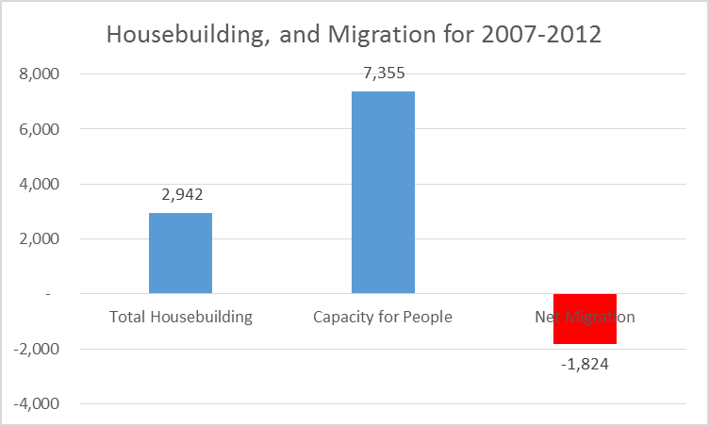The period 2007-2012 includes the final year of the boom, the recession and the now more moderate pace of economic growth that surely more closely represents future conditions. Indeed, as Figure 1 shows, taking the period 2007-2012, the HMA delivered 2,942 new dwellings which at an average of 2.5 people per dwelling created capacity for an extra 7,355 people to live in the area. Despite that, the HMA experienced an overall outward migration of 1,824 people. It surely cannot be considered sound to base the future housing “need” on increasing inward migration projections when recent data shows that in fact the HMA is undergoing net outward migration despite creating significant capacity for more people to live here.

Figure : Comparison of Housing Capacity and Migration 2007-2012

Accordingly, the additional 1,210 houses postulated in the SHMA arising from inward migration should be removed from the housing “need”.

## Average household size assumptions inappropriate

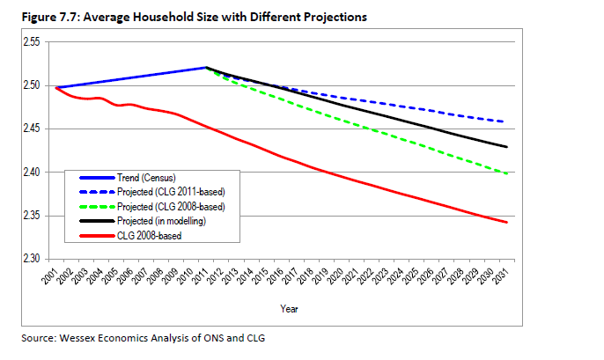

Figure : Figure 7.7 of the SHMA

Figure 7.7 of the SHMA (reproduced as Figure 2 above) shows that the trend in household size as measured by the census is slightly upward for the period from 2001 to 2011. This is in direct contradiction to both the 2008-based and 2011-based CLG projections. Yet the forward projections used in the SHMA reverse the trend shown in actual data in the census and persist with the inaccurate forecasts of a continuing fall in the average household size.

Part of the justification for this is given as “at the time of the 2011 Census, the British economy was still in recession”. This is factually incorrect as a cursory examination of the GDP numbers on the BBC website[3] shows that the economy came out of recession in mid-2009. It seems the forecasting “experts” are at a loss to properly explain this reversal of trend.

Moreover, given that the starting point for the SHMA projections is DCLG sourced figures, it would be somewhat odd for the DCLG forward projections not to include its own forecasts for household size. There is therefore a significant risk, that this part of the SHMA has double counted erroneous household size projections.

It is therefore inappropriate continue to assume a continuing downward trend in household size. Surely a more prudent assumption would be to assume that the current household size is maintained and update that assumption and the SHMA as more real data comes to light.

Accordingly, the 1,500 additional houses in the SHMA related to the flawed household size assumption should be removed.

## Jobs growth assumptions not credible

The SHMA uses a set of jobs growth assumptions that are based on forecasts that are vastly in excess of what has been achieved in the most recent economic cycle.

The SHMA contains data on the historic rates of job growth for the HMA. This shows two sets of data that are derived from different sources and cover different time periods (Figures 4.3 & 4.4 of the SHMA).

First, there is the period 1998-2008, covered by ABI data. This shows overall job growth in the period of 7,200, or 720 per annum for the 10 year period with a compound annual growth rate (CAGR) of 0.6%. Second there are different BRES sourced data for the periods of 2009-2012. The BRES data from 2009-2012 shows total jobs growth of 200, or 67 per annum for the 3 years in question or a CAGR of 0.05%.

Figure 3 shows a comparison of the BRES data and the ABI data that demonstrates the discontinuity between 2008 and 2009, with a jobs increase of nearly 10,000 when we know the economy was in the teeth of a deep recession. Note that the report states that the ABI and BRES data cannot be directly compared because they are compiled using different methods. It is therefore clear that each period (and dataset) should be treated separately and independently rather than splicing them together.

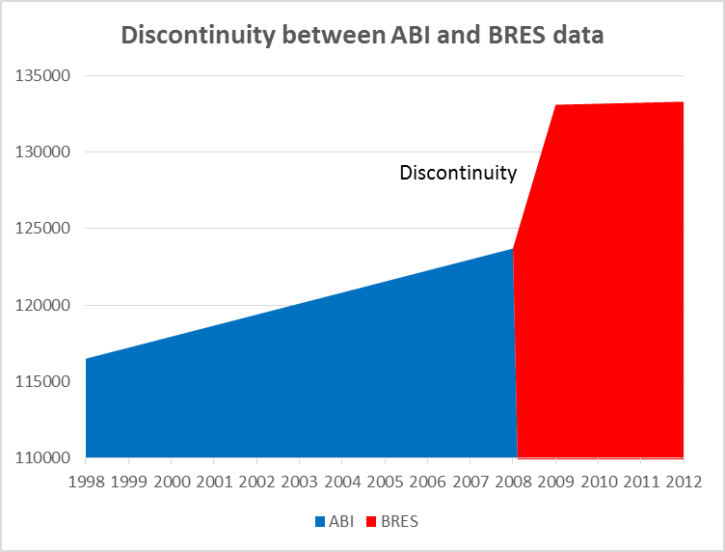

Figure 3: Discontinuity between ABI and BRES data

Treating the datasets separately would indicate total jobs growth over the economic cycle of 7,400, or 529 per annum or a CAGR of 0.41%, based on backward extrapolation of the BRES data.

Taking this 0.41% rate of growth as a future projection would mean we would add 11,332 overall jobs over the period of 2012-2032 at an average rate of 567 total jobs per annum.

However, the SHMA uses as its central assumption that future jobs growth of 1,130 per annum will be achieved, equating to a CAGR of ~0.79%, nearly double what was achieved over the most recent economic cycle and far higher than that achieved during the unsustainable boom of 1998-2008. Given the constraints on Government spending and tighter credit conditions that are likely to persist for some time due to tighter bank regulation, it is inconceivable that we will achieve an economic growth rate nearly twice that achieved during the last economic cycle. Figure 4 shows the comparison of these growth rates.

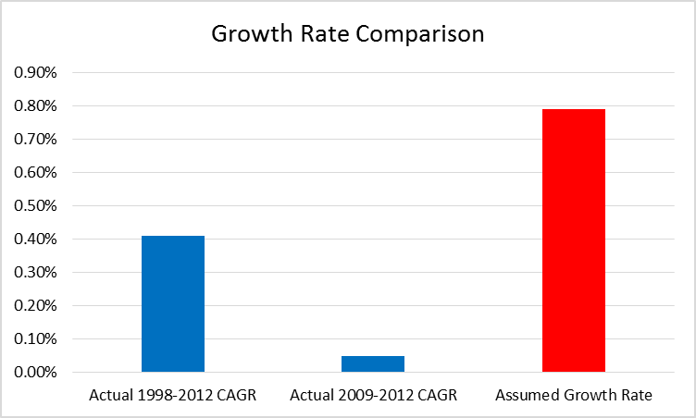

Figure 4: Comparison of Actual and Projected Growth Rates

Little justification for this is given other than it is based on Experian forecasts. The recent job creation history (2009-2012) showed jobs growth of 67 per annum as we came out of the recession. 67 jobs per annum equates to less than 6% of the jobs that the SHMA assumes we will create. This demonstrates that the Experian forecasts are pie in the sky and it beggars belief that such unproven Experian forecasts should take precedence over the actual real world achievement.

A further illustration of the outlandish nature of the Experian forecasts is given in para 7.70 of the SHMA.  In its forecast published in 2013, Experian assumes there were 145,000 jobs in the HMA in 2011.  Whereas the 2011 Census says there were only 122,300 and the BRES data says 125,000.  How can we trust Experian to forecast the future when it can’t even get the past right?

Even the Employment Land Review produced by Rushmoor Borough Council described the Experian forecasts as:

*“Experian-derived forecasts which are considered unreliably high in that they make too many assumptions around unconstrained economic growth”*

The SHMA also says at para 7.85:

*“…there are many ways labour markets can adjust to an increase in demand for labour that do not require an increase in the resident workforce. In summary these are:*

* *A reduction in unemployment*
* *A rise in economic activity rates*
* *A shift away from part time working to full time working*
* *An increase in double jobbing*
* *A reduction in out-commuting*
* *An increase in in-commuting*

*None of these changes require an increase in resident population, and all of them will be stimulated if  
wage and salary levels increase.*

*In the modelling, allowance has been made for only one of these effects…”*

It is clear that the employment forecasts are outlandishly large and the SHMA does not even take into account most of the ways in which jobs can increase without leading to a need for more housing.

Furthermore, if one compares the jobs forecasts to the population forecasts in the SHMA appendices, the overall forecasts imply a massive, unrealistic increase in the percentage of people of working age in employment as can be seen in Figure 5 below:



Figure 5: Comparison of %-age of population in employment

This shows an increase from around 70% of working age people in employment to 86-88%.  No explanation of the social changes that would lead to this change, nor any justification for this increase is given anywhere in the SHMA.

## Conclusions

From the above, it is clear we should not be basing our housing requirement on such unrealistic forecasts.

As noted above para 7 of the NPPG states that local communities should be involved

*“from the earliest stages of plan preparation, which includes the preparation of the evidence base in relation to development needs”.*

Moreover, a recent legal opinion from Peter Village QC[4] has said:

*“There has been no regulation 18 consultation at all on issues such as employment, retail, transport, infrastructure (or, indeed, anything other than housing distribution). It is inconceivable that a coherent and sound local plan could emerge without addressing most (at least) of these issues.”*

It therefore follows that the local community should be consulted upon the employment targets it wishes to set and the related scale of development required to meet that target.  No such consultation has taken place, nor is it planned which represents a significant flaw in the Local Plan process. The evidence from the We **♥** Hart[5] petition[6] indicates that local people are more likely to express a preference for a lower level of development.

Finally, despite enjoying high levels of employment, it is clear that we need to change the way we forecast jobs growth in the area as past methods have resulted in vast amounts of unused employment land and vacant retail outlets with examples illustrated [here](http://wehearthart.co.uk/2015/02/how-do-we-regenerate-our-high-streets/)[7] and [here](http://wehearthart.co.uk/2015/01/only-700-houses-on-brownfield-land/)[8].

The overall impact of correcting these erroneous assumptions would be to reduce the overall housing target for the combined area by around 7,800 units.  This would reduce Hart’s overall housing target to around 6,100 units and crucially reduce Rushmoor and Surrey Heath’s target so they don’t need to ask Hart to build 3,100 houses for them.

# Appendix B: Potential Capacity of the Wellesley Development

## Wellesley

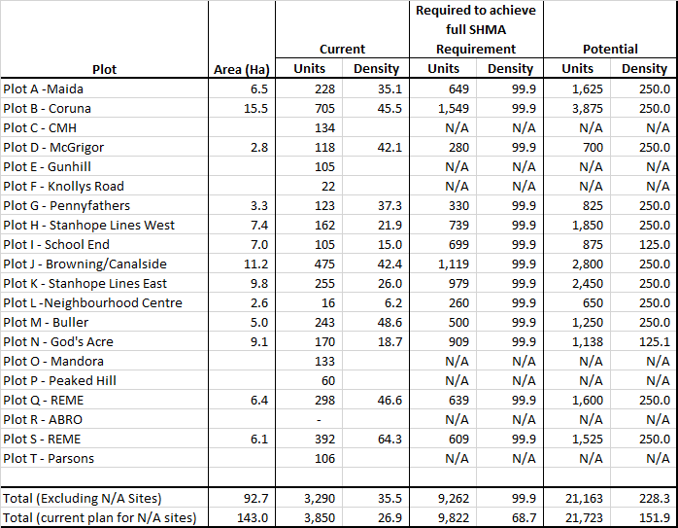

Figure B1: Wellesley Planning Densities

The centrepiece of Rushmoor's development strategy in the draft Local Plan is the Wellesley development[9] (formerly known as the Aldershot Urban Extension).

This is a 143 hectare development where 3,850 new dwellings are planned houses.  This amounts to a very modest density of only 26.9 dwellings per hectare (dph) across the whole area, even lower than Hart's planning assumption of 30dph.  Across the plots digitised by Gareth Price, the density rises to 35.5dph which is still very low for an urban area (se Figure B1).

If Rushmoor were to alter the draft plans for Wellesley to an easily achievable 68.7dph, they could meet the entire assessed housing need of 9,822 up to 2032 without even touching the other sites in the SHLAA leaving additional capacity for future years or for neighbouring districts.

Modern planning techniques as outlined by Gareth Price[10], suggests that thriving, sustainable communities can be created in urban areas with planning densities in the range of 150-250dph.  Moving to around 152dph would give capacity at Wellesley for over 21,500 units, giving sufficient capacity for Rushmoor for decades to come without utilising any other sites in Aldershot or Farnborough. This could potentially make available other brownfield sites in Rushmoor for other districts.

## Other sites

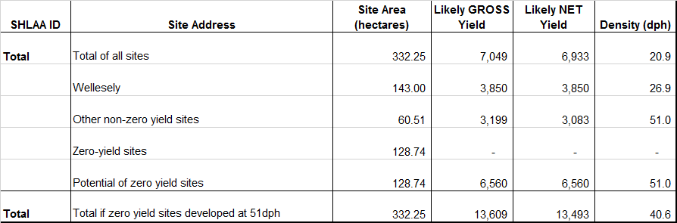Examination of Rushmoor's full SHLAA[11] as shown in Figure B1, demonstrates that outside Wellesley, Rushmoor have identified 60.51Ha with a planned density of 51dph yielding 3,083 units largely on brownfield sites in Aldershot and Farnborough. In addition, 128.74Ha of additional brownfield sites are shown where they are not currently planning to build any houses (zero yield sites).  If these sites were planned to deliver at the same 51dph, they would yield an additional 6,560 units.  Without changing Wellesley, this would bring the available total capacity up to 13,493 units (or density could be increased on the 60.51Ha), far in excess of the assessed need of 9,822.

Figure B2: Analysis of Rushmoor SHLAA

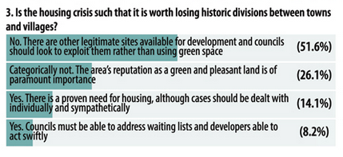

Figure B: Survey of Hampshire residents

As can be seen, if Rushmoor gets more creative with Wellesley, and plans to build on the zero-yield sites it has already identified, there is potential capacity for a total of over 30,000 dwellings, more than three times its (overblown) assessed need.   It surely cannot be too much to expect that the 1,600 houses Rushmoor say they can't build can be found within this wealth of opportunity. Rushmoor Borough Council should re-visit its planned densities and seek to meet all of its assessed need within in its own boundaries.  It could then make some sites available for neighbouring rural districts in line with a recent survey of Hampshire[12] (Figure B3) residents seeking to protect rural areas.  Neighbouring districts could be approached to provide SANG capacity if required

Sources:

* Wellesley Delivery strategy: <http://www.rushmoor.gov.uk/CHttpHandler.ashx?id=10353&p=0>
* A sustainable approach to building on brownfield sites in Hart District and Rushmoor: <http://wehearthart.co.uk/sdm_downloads/a-sustainable-approach-to-building-on-brownfield-sites-in-hart-district-and-rushmoor/>
* Hart and Rushmoor can meet their housing needs from brownfield sites for 50 years or more: <http://wehearthart.co.uk/2015/06/hart-district-and-rushmoor-can-meet-their-housing-needs-from-brownfield-sites-for-50-years-or-more/>
* Housing Density Study, Maccreanor Lavington Architects; Emily Greeves Architects and Graham Harrington Planning Advice : <http://wehearthart.co.uk/wp-content/uploads/2015/03/Housing-density-study-opt.pdf>
* Rushmoor SHLAA: <http://wehearthart.co.uk/wp-content/uploads/2015/06/Rushmoor-Borough-Council-RBC-SHLAA-assumptions.xlsx>
* SHLAA Analysis: <http://wehearthart.co.uk/2015/06/rushmoor-has-potential-capacity-for-over-30000-homes/>
* Pre-election poll showing Hampshire residents wish to protect green space: <http://wehearthart.co.uk/2015/04/hampshire-residents-say-protecting-our-towns-and-villages-is-a-key-election-issue/>
* Other data: <http://wehearthart.co.uk//2015/06/please-help-hart-fend-off-an-extra-1600-houses-from-rushmoor/>

# Appendix C: Errors in the Employment Land Review

[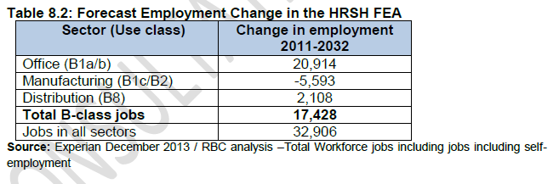](http://wehearthart.co.uk/wp-content/uploads/2015/05/ELR-Figure-8.2.png)

Figure 1: Table 8.2 of the ELR

The starting point for the analysis is Table 8.2 of the ELR that shows the forecast employment change in a number of different types of jobs, from which it is possible to derive the ratio of B-Class jobs to all jobs at 53% (17,428/32,906).  Then we must look at Figure 7.12 that allegedly compares the historic rate of growth of B-Class jobs to the forward projections.

[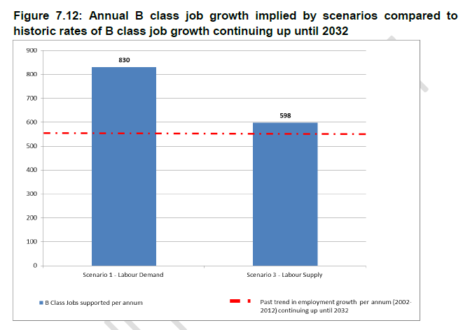](http://wehearthart.co.uk/wp-content/uploads/2015/05/Figure-7.12-ELR.png)

Figure 2: Figure 7.12 of the ELR

By inspection, Figure 7.12 shows the trend in B-Class jobs as approximately 555 per annum from 2002-2012.  The data from Table 8.2 allows us to derive total job growth of around 1,048 per annum.  However, as we shall show below, this number is far in excess of the actual job growth achieved according to the SHMA.

The SHMA contains data on the historic rates of job growth.  This shows two sets of data that are derived from different sources and cover different time periods (Figures 4.3 & 4.4 of the SHMA).

First, there is the period 1998-2008, covered by ABI data.  This shows overall job growth in the period of 7,200, or 720 per annum for the 10 year period with a compound annual growth rate (CAGR) of 0.6%.  This would equate to a growth rate of B-Class jobs of 382 per annum, far lower than the 555 jobs per annum shown in figure 7.12.

Second there are different BRES sourced data for the periods of 2009-2012. The BRES data from 2009-2012 shows total jobs growth of 200, or 67 per annum (35 B-Class per annum) for the 3 years in question or a CAGR of 0.05%, again far lower than the 555 for B-class only jobs growth in figure 7.12.  It is difficult to see how the 555 B-class jobs growth number was derived since it is much higher than either period covered in the SHMA.

Comparison of the BRES data and the ABI data shows a discontinuity between 2008 and 2009, with a jobs increase of nearly 10,000 when we know the economy was in the teeth of a deep recession. Note that the report states that the ABI and BRES data cannot be directly compared because they are compiled using different methods. It is therefore clear that each period (and dataset) should be treated separately and independently rather than splicing them together.

Treating the datasets separately would indicate total jobs growth over the economic cycle of 7,400, or 529 per annum or a CAGR of 0.41%, based on backward extrapolation of the BRES data.  This would equate to B-Class jobs growth rate of 280 per annum, or about half the number in Figure 7.12 of the ELR.

Taking the 0.41% rate of growth as a future projection would mean we would add 11,332 overall jobs over the period of 2012-2032 at an average rate of 567 total jobs per annum, or around 300 B-Class jobs per annum.

However, the scenario recommended for testing in the ELR assumes a rate of B-Class jobs growth of 598 per annum (or total jobs growth of 1,128 per annum), nearly double the rate that would represent a forward projection of past performance over the economic cycle and very close to the overall job creation number in the SHMA that is based on Experian jobs forecasts.

The ELR itself describes the Experian jobs forecasts as:

*“Experian-derived forecasts which are considered unreliably high in that they make too many assumptions around unconstrained economic growth”,*

It is therefore clear that the ELR is based on unrealistic jobs growth and seeks to protect more employment land than is necessary. This additional employment land could be freed up for housing.

Sources from: <http://wehearthart.co.uk/2015/05/rushmoors-employment-land-review-has-errors-that-reduce-brownfield-site-availability/>

1. <http://planningguidance.planningportal.gov.uk/blog/guidance/housing-and-economic-development-needs-assessments/the-approach-to-assessing-need/>
2. <https://you.38degrees.org.uk/petitions/we-hart>
3. <http://www.bbc.co.uk/news/10613201>
4. <http://wehearthart.co.uk/2015/05/top-qc-says-hart-councils-position-on-the-local-plan-is-hopeless/>
5. <http://wehearthart.co.uk>
6. <https://you.38degrees.org.uk/petitions/we-hart>
7. <http://wehearthart.co.uk/2015/02/how-do-we-regenerate-our-high-streets/>
8. <http://wehearthart.co.uk/2015/01/only-700-houses-on-brownfield-land/>
9. <http://www.rushmoor.gov.uk/CHttpHandler.ashx?id=10353&p=0>
10. <http://wehearthart.co.uk/2015/06/hart-district-and-rushmoor-can-meet-their-housing-needs-from-brownfield-sites-for-50-years-or-more/>
11. <http://wehearthart.co.uk/wp-content/uploads/2015/06/Rushmoor-Borough-Council-RBC-SHLAA-assumptions.xlsx>
12. <http://wehearthart.co.uk/2015/04/hampshire-residents-say-protecting-our-towns-and-villages-is-a-key-election-issue/>